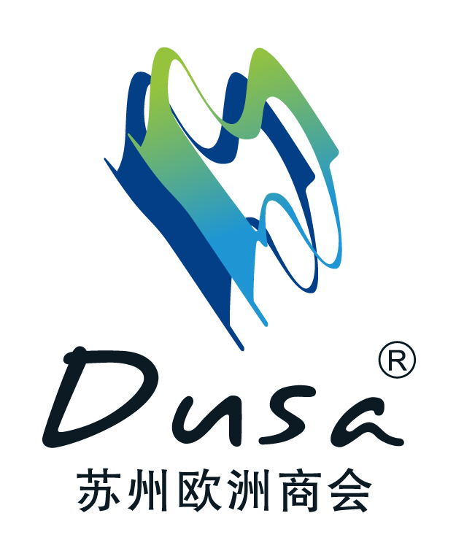
DUSA Football Tournament 2025 Entry Form

Company Name (EN&CN) | Team Name(EN&CN) | Team Captain(EN&CN) | Contact Details
 |  | Name | Direct Line:  Mobile:  E-mail:

No | Full Name(EN&CN) | Birthday date  (For Insurance) | ID number or Passport numbers (For Insurance) | Contacts  (For Insurance)
Mobile:
E-mail:
Organizing Committee Contacts

Michelle Xue | DUSA European Association Suzhou | Business Manager | Mobile: +86 185 5128 3058  E-mail: biz@dusa-eu.cn

Please send back the entry form and pay for your teams’ entry fee before April 17th.

